**REPORT**

|  |
| --- |
| **Experiment 1: Voltage divider simulation** |

**NOTICE: PLEASE MARK APPROPRIATE “LABEL” ON YOUR SCHEMATIC**

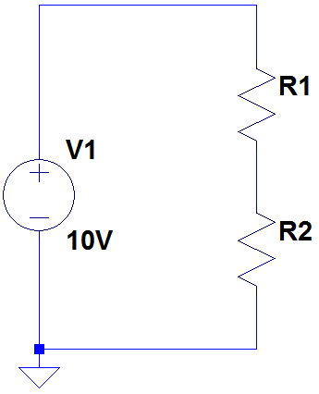

|  |  |  |
| --- | --- | --- |
| Condition | voltage（VR1） | voltage（VR2） |
| 1. R1=34Ω, R2=66Ω | **3.4V** | **6.6V** |
| 2. R1=3MΩ, R2=7MΩ | **3V** | **7V** |

Please screenshot your result and paste here. It have to include VR1 label and VR2 label .

|  |  |
| --- | --- |
| Condition 1： | Condition 2： |

|  |
| --- |
| **Experiment 2: RC circuit simulation** |

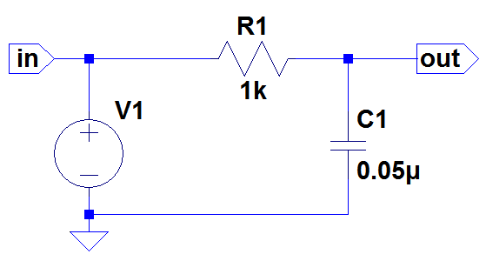

$V_{1}：5 Vpp、1000Hz、0V offset$ Impulse.

Plot the waveform of node “in” and node “out” in the same graph. Show only one cycle.

The color of node “in” is blue . The color of node “out” is red .

Paste the screenshot in the below table.

|  |
| --- |
| RC circuit in LTSpice with label VR1： |
| LTSpice’s waveform： |

Question:

How do you choose every parameter in above simulation command? (e.g. how to decide “Stop Time” should be, etc..)

|  |
| --- |
| **Experiment 3: RL circuit simulation** |

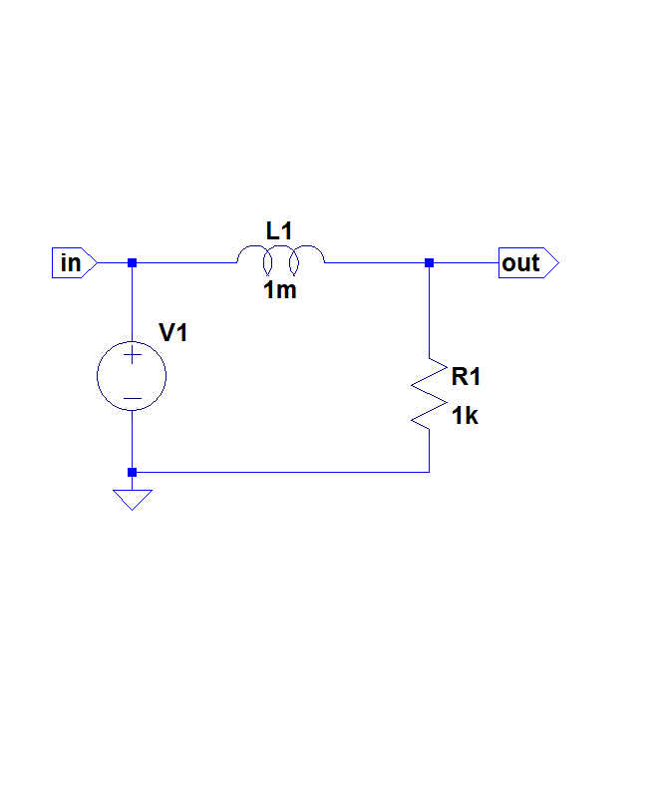

$V_{1}：5 Vpp、1000Hz、0V offset$ Impulse

Plot the waveform of node “in” and node “out” in the same graph. Show only one cycle.

The color of node “in” is blue . The color of node “out” is red .

Paste the screenshot in the below table.

|  |
| --- |
| RL circuit in LTSpice with label VL1： |
| LTSpice’s waveform： |

Question:

How do you choose every parameter in above simulation command? (e.g. how to decide “Stop Time” should be, etc..)